# Lab-11-1: Serverless Computing: AWS Lambda Service

# Objectives

* Create a Lambda function to print input
* Configure a Lambda function to copy files from a S3 bucket to another



--------------------------------------------------------------------------------------------------

**Today:**

Login to awseducate.com

Select Accounts

Go to Starter account

Click on AWS console

**Task1: Create a Lambda function to print Uploaded /Deleted File Name on S3 Bucket**

1. You will create a Lambda function
2. Write python code to print input
3. Examine output
4. Triggering Lambda from S3 events

Create a Lambda function

---------------------------------------

* Select Lambda from the services
* Functions -> Create Function
* Use a Blueprint
* Type “hello”
* Select “hello-world python”
* Name it “hello_lambda”
* Create a new role
* Create Function
* On the code editor under function code

Uncomment the line with Jason dump

Save the file

* Click on the Test button
* Create a new Test event
* Event name “Test11’
* Create

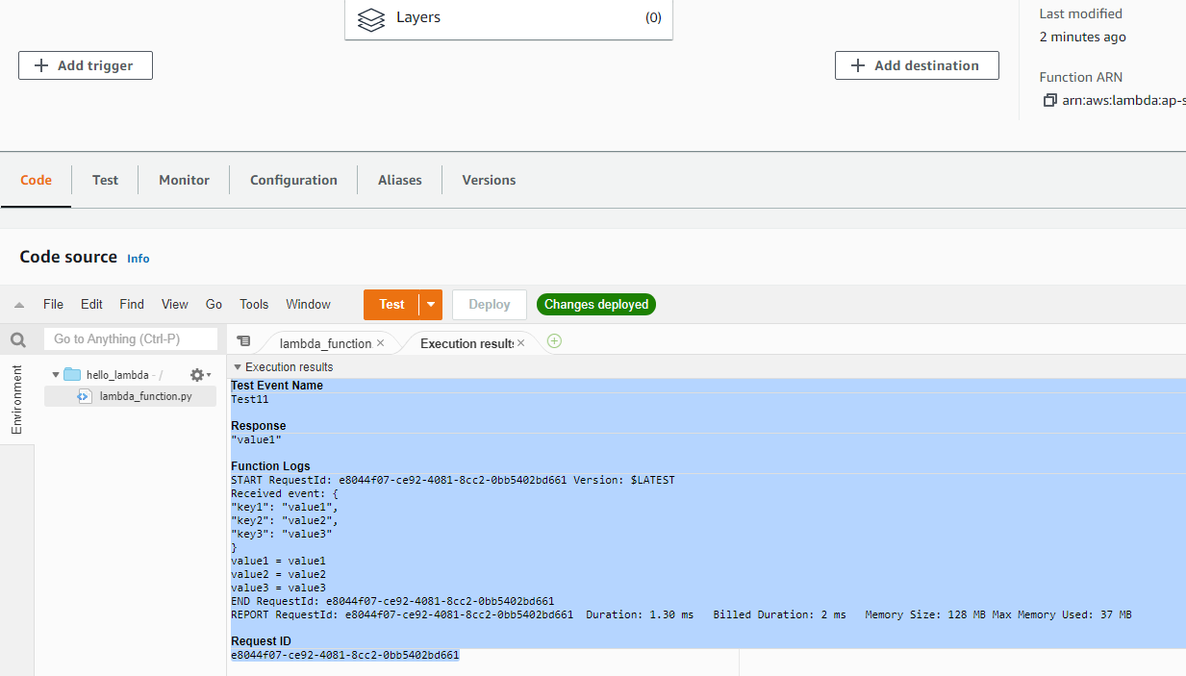

Q1. What does this Test do?

* Run the Test
* Prints three values to the terminal/screen

Q2. Explain the Execution Result

Challenge Problem: Triggering Lambda from S3 Events

Create an AIM role to allow Lambda to have full access to S3 service

Create a new S3 bucket

On the S3 properties select Events and new event

Send to Lambda

Select the destination as the Lambda function

Save it

Every time a file is uploaded or deleted on the S3 bucket the Lambda function should only print the name of the File that was uploaded on S3

[Hints: https://www.tutorialspoint.com/aws_lambda/aws_lambda_using_lambda_function_with_amazon_s3.htm]

